## MINI PROJECT-I REPORT

**(22ITC07)**

**on**

**SKILLSPHERE**

**Submitted in partial fulfilment for the completion of**

**BE-IV Semester**

**in**

**INFORMATION TECHNOLOGY**

**By**

**M. Srujan Nayak (160123737189)**

**Imtisal Rangrez (160123737180)**

**Under the guidance of**

**E.Ramalakshmi**

**Assistant Professor,**

**Dept. of IT**



**DEPARTMENT OF INFORMATION TECHNOLOGY**

**CHAITANYA BHARATHI INSTITUTE OF TECHNOLOGY**

***(Autonomous)***

**(Affiliated to Osmania University; Accredited by NBA(AICTE) and NAAC(UGC), ISO Certified 9001:2015)**

**GANDIPET, HYDERABAD – 500 075**

**Website:** [**www.cbit.ac.in**](http://www.cbit.ac.in)

**2024-2025**



**CERTIFICATE**

This isto certify that the project work entitled “**SKILLSPHERE**” submitted to **CHAITANYA BHARATHI INSTITUTE OF TECHNOLOGY,** in partial fulfilment of the requirements for the award of the completion of Mini Project-I (22ITC07) IV semester of B.E in Information Technology, during the academic year 2024-2025, is a record of original work done by **Srujan Nayak (160123737189), Imtisal Rangrez (160123737180)** during the period of study in Department of IT, CBIT, HYDERABAD, under our supervision and guidance.

**Project Guide**  **Head of the Department**

**E. Ramalakshmi Dr.M. Venu Gopalachari**

Asst. Professor, Dept. of IT, Professor, Dept. of IT,

CBIT, Hyderabad. CBIT, Hyderabad.

**TABLE OF CONTENTS**

|  |  |  |
| --- | --- | --- |
| CERTIFICATE | | ii |
| TABLE OF CONTENTS | | iii |
| LIST OF FIGURES AND SCREEN SHOTS | | iv |
| LIST OF TABLES | | v |
| ACKNOWLEDGEMENTS | | vi |
| ABSTRACT | | 6 |
| 1. | **INTRODUCTION** | 7 |
|  | 1.1. Motivation | 7 |
|  | 1.2. Problem Statement | 8 |
|  | 1.3. Objectives | 9 |
| 2. | **EXISTING SYSTEM** | 10 |
| 3. | **PROPOSED SYSTEM** | 11 |
|  | 3.1. Methodology | 12 |
|  | 3.2. Architecture of Proposed System | 13 |
| 4. | **SOFTWARE & HARDWARE REQUIREMENTS** | 15 |
| 5. | **IMPLEMENTATION OF PROJECT** | 17 |
|  | 5.1. Development steps | 17 |
|  | 5.2. Execution steps | 23 |
|  | 5.3. Results | 24 |
| 6. | **CONCLUSION & FUTURE SCOPE** | 35 |
| 7. | **CHALLENGES/DIFFICULTIES FACED** | 37 |
| **BIBLOGRAPHY** | | 38 |

**LIST OF FIGURES AND SCREENSHOTS**

|  |  |  |
| --- | --- | --- |
| **Figure No.** | **Description** | **Page No.** |
| Fig. 1.1 | Registration page | 24 |
| Fig. 1.2 | login page | 25 |
| Fig. 1.3 | Facilities page | 26 |
| Fig. 1.4 | Continuation of Facilities page | 26 |
| Fig. 1.5 | Interface between the sports page and the courts list page | 28 |
| Fig. 1.6 | courts page | 28 |
| Fig. 1.7 | Reservation Page | 30 |
| Fig. 1.8 | My Reservations Page | 31 |
| Fig. 1.9 | Error 1 | 31 |
| Fig. 2.1 | Error 2 | 33 |

**LIST OF COLLECTIONS:**

|  |  |  |
| --- | --- | --- |
| **Table No.** | **Description** | **Page No.** |
| Table 1.1 | **User emails table/database** | 24 |
| Table 1.2 | **Facilities table/database** | 27 |
| Table 1.3 | **Courts table/database** | 39 |
| Table 1.4 | **Timeslot table/database** | 32 |
| Table 1.5 | **Reservations table/database** | 33 |

**ACKNOWLEDGEMENTS**

We would like to express our heartfelt gratitude to all those who supported and guided us throughout the development of this project.

Primarily, we sincerely thank **Mrs. E. Ramalakshmi**, Assistant Professor, Department of Information Technology, for her constant support, expert guidance, and valuable suggestions during every stage of the project. Her encouragement and insights greatly enhanced the quality of our work and helped us overcome various challenges.

We are also grateful to the faculty and staff of the Department of Information Technology for providing us with the necessary facilities and a collaborative environment that enabled us to complete this project successfully.

We extend our sincere thanks to our families and friends for their unwavering support, motivation, and encouragement throughout this journey.

This project, **SKILLSPHERE**, was undertaken as a collaborative effort by:

**Srujan Nayak Roll Number: 160123737189**

**Imtisal Rangrez Roll Number: 160123737180**

**ABSTRACT**

This document presents SportSched, a web-based reservation platform aimed at optimizing the allocation of sports courts in educational institutions. Acknowledging the difficulties associated with limited facility access and the necessity for fair distribution, SportSched utilizes a multi-layered prioritization algorithm that incorporates essential factors such as students' class schedules, past court usage frequency, and academic standing based on their year of study. The system first cross-references class schedules to reduce potential conflicts with academic obligations. It then prioritizes reservations by giving preference to students who have made fewer previous bookings, thereby fostering equitable access to sports facilities. In instances where these criteria result in similar priorities, the system further distinguishes requests based on students' academic year, ensuring that junior students receive appropriate consideration. It utilizes a multi-layered prioritization algorithm built with modern technologies, including React for the frontend, Django for the backend, and SQLite3 for database management, to incorporate essential factors such as students' class schedules, past court usage frequency, and academic standing based on their year of study. With its intuitive interface and real-time scheduling features, SportSched not only streamlines the management of sports court reservations but also promotes increased participation in physical activities among the student body. This document elaborates on the system's design framework, algorithmic decision-making process, and the expected advantages in improving facility utilization and encouraging a healthier, more active campus atmosphere.

**1.INTRODUCTION**

The SportSched initiative is an all-encompassing system for sports reservations and scheduling, aimed at optimizing the management of sports facilities and bookings. It features a powerful backend for data processing and business logic, paired with an intuitive frontend interface for effortless user interaction. This system is tailored to meet the requirements of sports facility managers and users, promoting effective scheduling, reservation oversight, and user participation.

**1.1 MOTIVATION**

The main objective of this initiative is to motivate students to engage in sports by tackling a significant obstacle: the lack of accessible sports facilities when required. Many students tend to lose interest or motivation to participate when they arrive at a facility only to discover it is already in use or unavailable. This uncertainty often results in frustration, disinterest, and a gradual decrease in their involvement in sports. Another significant issue students encounter is the absence of real-time updates regarding the availability of different sports facilities. Without a centralized platform or system, students frequently remain unaware of which facilities are free, occupied, or undergoing maintenance. This information gap leads to confusion, scheduling conflicts, and missed chances for physical activity. The aim of this project is to establish a user-friendly, transparent, and accessible reservation system that enables students to check availability and reserve sports facilities in advance. This approach not only cultivates a more organized sports environment but also encourages a culture of consistent physical activity among students.

**1.2 Problem Statement**

The main objective of this initiative is to motivate students to engage in sports by tackling a significant obstacle: the lack of accessible sports facilities when required. Many students tend to lose interest or motivation to participate when they arrive at a facility only to discover it is already in use or unavailable. This uncertainty often results in frustration, disinterest, and a gradual decrease in their involvement in sports. Another significant issue students encounter is the absence of real-time updates regarding the availability of different sports facilities. Without a centralized platform or system, students frequently remain unaware of which facilities are free, occupied, or undergoing maintenance. This information gap leads to confusion, scheduling conflicts, and missed chances for physical activity. The aim of this project is to establish a user-friendly, transparent, and accessible reservation system that enables students to check availability and reserve sports facilities in advance. This approach not only cultivates a more organized sports environment but also encourages a culture of consistent physical activity among students.

**1.3 OBJECTIVES**

**Unified Booking Platform for Sports Facilities**

The system is crafted to provide a centralized interface where students can easily access and reserve sports facilities, eliminating the need for manual processes or administrative involvement. This enhances the booking process and minimizes confusion.

**Real-Time Facility Availability Tracking**

A key goal is to deliver current information regarding the availability of each sports facility. This real-time monitoring enables students to better organize their activities and prevents them from wasting time on already occupied facilities.

**Efficient Resource Utilization**

By effectively managing time slots, the system seeks to minimize downtime and maximize the use of available sports resources. Proper scheduling and booking facilitate accommodating more students throughout the day.

**Promoting Sports Engagement**

Accessible facilities can greatly boost student enthusiasm for sports participation. With a dependable system in place, students are more inclined to establish a regular routine and remain physically active. Secure User Authentication and Role-Specific Access The system will feature secure login protocols for various users. Students will have the ability to view and reserve facilities, while administrators will manage bookings, update schedules, and oversee usage.

**2.EXISTING SYSTEM**

The current system for booking and accessing sports facilities at the college is entirely manual, presenting significant challenges for both students and administrative personnel.

Students must physically approach the relevant authority, typically a sports coordinator or administrative office, to check availability and secure a booking. This manual approach has numerous limitations that adversely affect overall efficiency and the student experience.

Firstly, there is no centralized or real-time method to verify facility availability, forcing students to depend on informal communication or make several visits to ascertain whether a facility is free, often resulting in miscommunication and scheduling conflicts.

Consequently, students may arrive at facilities that are occupied, despite having been informed otherwise. Secondly, the lack of adequate record-keeping leads to confusion and mismanagement. Bookings are generally recorded in registers or spreadsheets, which are susceptible to errors, duplication, or even loss. This complicates the tracking of past usage and the management of cancellations, resulting in underutilization or double bookings of facilities. Furthermore, the manual approval process is laborious, often requiring multiple layers of authorization. This not only prolongs the booking process but also discourages students from engaging in spontaneous or last-minute sports activities. The rigidity of the system and the effort needed to secure a booking serve as significant obstacles, particularly for students with demanding academic commitments.

Finally, the lack of transparency within the system hampers students' ability to plan their activities effectively. There is no mechanism to inform students of changes in availability, maintenance schedules, or special reservations, leading to wasted time and frustration.

**3.PROPOSED SYSTEM**

The proposed system is a digital platform meticulously crafted to address the shortcomings and inefficiencies associated with the current manual booking process for sports facilities at the college. This system is designed to facilitate convenient and efficient bookings for students through a centralized online portal. Its objective is to provide a user-friendly, transparent, and real-time booking experience that motivates students to participate more actively in sports by removing the delays and frustrations inherent in manual booking methods. This system allows students to log in with their credentials and view available time slots for various sports facilities. Upon selecting a slot, the system verifies its availability against the database. If the slot is available, it is booked, and the student receives instant confirmation.

Additionally, the system enables users to access their booking history, cancel existing reservations. For administrative purposes, the platform features a dashboard that facilitates facility management, booking approvals or denials, time slot updates, maintenance block period settings, and usage statistics tracking over time. The primary goal of this system is to foster a vibrant sports culture within the institution by making participation more accessible and organized. With real-time availability checks and booking confirmations, students can better plan their activities without concerns about scheduling conflicts or confusion. Furthermore, it alleviates the administrative burden by reducing paperwork and minimizing human error. The system enhances transparency by making facility schedules publicly accessible and eliminating the possibility of overlapping bookings or unofficial reservations. Ultimately, this platform not only promotes better utilization of sports resources but also encourages physical activity among students by providing a seamless method for accessing college sports facilities.

**3.1 METHODOLOGY**

This project is being developed using the Waterfall Model, a conventional approach to software development characterized by a linear and sequential progression. This model was chosen for its straightforwardness, well-defined structure, and clear project scope. Each development phase is completed in order, ensuring that requirements are thoroughly gathered before moving on to design, implementation, testing, and deployment.

During the requirement analysis phase, the main objective was to comprehend the limitations of the existing manual system. Input was solicited from both students and administrators to pinpoint specific issues they faced, including double bookings, absence of real-time availability, and the lengthy nature of the booking process. After identifying these problems, we delineated the functional requirements for the system, which included user authentication, facility availability, booking management, and real-time notifications.

Subsequently, the design phase commenced, focusing on planning the overall architecture and system components. This phase involved designing the frontend user interface with React to ensure a dynamic and responsive user experience, as well as developing the backend with Django, which is responsible for managing requests, processing data, and overseeing authentication. The database structure was also established during this phase, with SQLite3 selected for its lightweight and user-friendly characteristics, making it suitable for the scale of this project. The implementation phase entailed the actual development of the system, where both the frontend and backend were coded and integrated. The user interface was constructed in React to provide a seamless and interactive experience, while the backend was developed using Django to manage database queries, user management, and booking functionalities. The SQLite3 database was configured to oversee data such as user information, facility details, and booking records.

**3.2 ARCHITECTURE OF THE PROPOSED SYSTEM**

The architecture of the proposed system follows a three-tier architecture, which divides the system into three distinct layers: the Presentation Layer, the Application Layer, and the Database Layer. This architecture is designed to ensure modularity, ease of maintenance, and scalability. Each layer performs specific tasks, allowing for a more organized development and efficient management of the system.

The Presentation Layer is the user interface of the system, developed using React. This layer is responsible for presenting information to users and capturing their input. It is dynamic, providing an interactive experience where students can easily browse available facilities, make bookings, view their booking history, and receive notifications. React component-based architecture ensures that the user interface is responsive and can be easily maintained or extended in the future. The frontend communicates with the backend via API calls, ensuring smooth data exchange between the user and the system.

The Application Layer serves as the core of the system, managing the business logic and all interactions between the user interface and the database. Built using Django, this layer is responsible for processing user requests, such as booking a facility, checking availability, or updating user details. It also ensures that only valid and authenticated users can access specific functionalities, such as booking slots or modifying their personal information. Django’s built-in features, like routing, form handling, and user authentication, help streamline the development process while ensuring security and efficiency.

The Database Layer uses SQLite3 to store all system data. This includes user details, facility information, available slots, booking records, and administrative updates. SQLite3 is lightweight and ideal for small to medium-scale applications, making it perfect for this project. The database is designed with relational tables, ensuring data integrity and consistency. For instance, when a student books a facility, the system checks the availability in the database and updates the relevant records to reflect the new booking. The interaction between these three layers ensures that the system functions smoothly. The Presentation Layer collects user inputs and displays results, which are processed by the Application Layer. The Application Layer interacts with the Database Layer to retrieve or store data as needed. This separation of concerns ensures that each layer can be developed, assessed, and maintained independently, while still working cohesively to deliver a fully functional system.

This architecture is scalable and can be easily extended with additional features in the future, such as advanced reporting, mobile support, or integration with external systems. The modularity of the three-tier architecture also makes it easier to debug and maintain, ensuringthat the system can evolve with the changing needs of the institution.

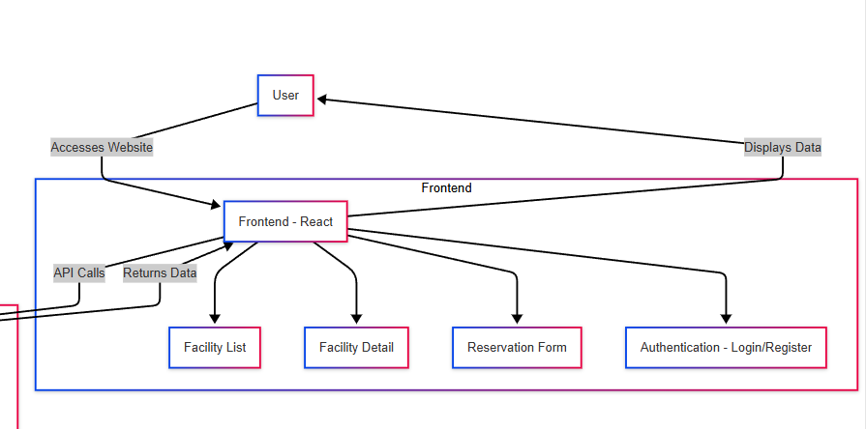

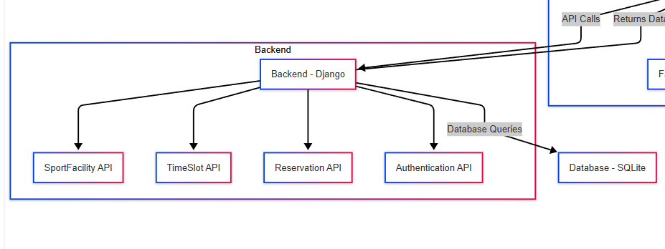

**4.SOFTWARE AND HARDWARE REQUIREMENTS**

**Software Requirements**

The development and deployment of the sports facility reservation system require the use of specific software components to ensure smooth functionality. The system can be developed and deployed on popular operating systems such as Windows, Linux, or macOS. These platforms provide the necessary environment for running both backend and frontend components of the application.

The backend of the system is built using Django, a Python-based framework that supports rapid web development. Django provides essential features such as database management, user authentication, and routing. It simplifies the creation of complex, database-driven websites and ensures scalability and security.

**Python,** version 3.8 or higher, is the programming language used for the development of the backend logic of the system. Python is selected for its simplicity, flexibility, and compatibility with the Django framework.

For frontend development, **React** is employed. React is a JavaScript library used for building user interfaces, and it allows for the creation of dynamic and interactive components, enabling users to view and interact with sports facility schedules and bookings in real-time.

**SQLite3** is used as the database management system in this project. SQLite3 is a lightweight, serverless, self-contained database engine that stores all the data such as user credentials, booking details, and sports facility schedules.

**Git** is used for version control to manage the source code and track changes made during the development process. Git enables multiple developers to collaborate efficiently and maintain the integrity of the project. GitHub or GitLab platforms are used for hosting and managing the code repositories, ensuring collaborative development, and providing an effortless way to store backups and track progress.

**Visual Studio Code (VS Code)** or PyCharm are the integrated development environments (IDEs) used for writing, testing, and debugging the code. These IDEs offer advanced features such as syntax highlighting, code suggestions, and debugging tools, making the development process easier and more efficient.

For testing and using the application, a modern web browser such as Google Chrome, Mozilla Firefox, or Safari is required to ensure cross-browser compatibility and responsiveness.

**Hardware Requirements**

Ensure the smooth development, testing, and deployment of the sports facility reservation system, the following hardware specifications are recommended:

A minimum of an Intel i3 processor or equivalent is required, though an Intel i5 or higher processor is recommended for better performance during development. A more powerful processor ensures the smooth handling of multiple processes, such as server-side development, database management, and frontend testing.

The system should have at least 4GB of RAM, although 8GB RAM or higher is recommended for seamless multitasking, faster processing, and better handling of the integrated development environment (IDE), web browser, and database systems.

For storage, a minimum of 20GB of free hard disk space is required for storing project files, development tools, and database files. It is recommended to have 50GB or more of free space to accommodate growing project files, dependencies, and the database, ensuring enough room for future updates and extensions.

A stable internet connection is required for downloading dependencies, libraries, and tools during the development phase. Additionally, an internet connection is necessary for deploying the application to the web server and conducting online testing.

A display with a resolution of 1280 x 800 or higher is recommended to provide clear visibility while working in the development environment. A higher resolution allows efficient interaction with the code and user interfaces.

**5.IMPLEMENTATION OF THE PROJECT**

The development of the Sports Facility Reservation System follows a systematic approach that combines the work of the backend and frontend components. The process is broken down into several stages, beginning with setting up the development environment and concluding with testing and deployment.

**5.1 DEVELOPMENT STEPS**

**1. Setting Up the Development Environment**

The initial phase involves setting up the necessary tools and environment for both the backend and frontend. For the backend, the project leverages Django, while the frontend is constructed with React. Below is the guide for preparing the development environment:

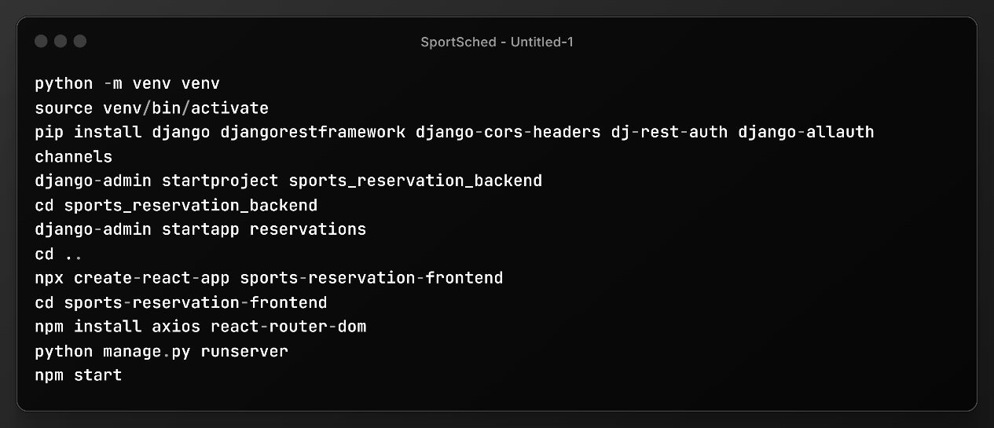

**2. Backend Implementation**

The backend logic is built using Django, a powerful Python framework that facilitates rapid development and efficient handling of requests. The backend is responsible for processing user inputs, managing data in the database, and handling user authentication. Below is the implementation of key components:

**Models (Database Schema)**

Django models define how the database tables are structured. For this system, models are designed for users, facilities, and reservations. Here’s an example of how to create models:

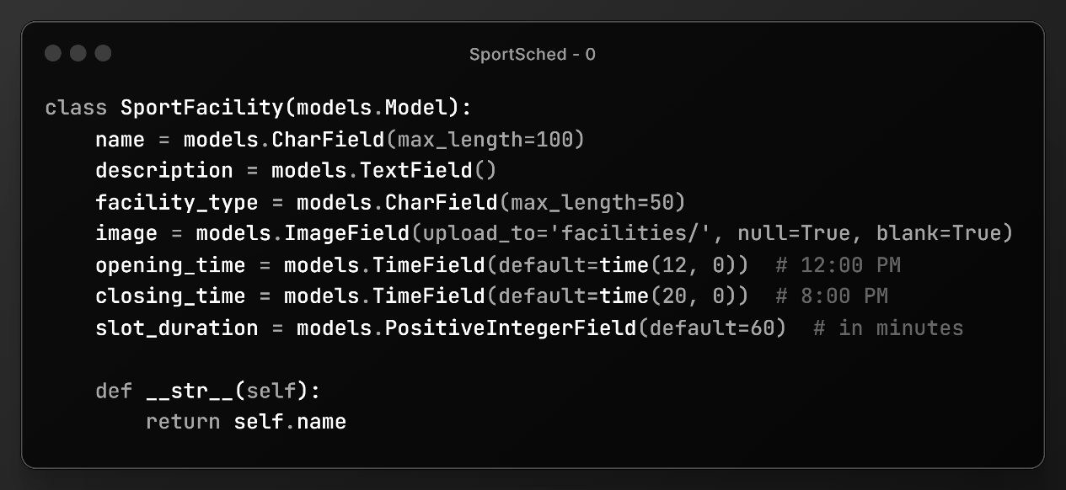

These are some of the view sets of the whole project just to illustrate the implementation.

**Views and Routes**

The views oversee incoming requests, process them, and send back responses. Below is an example of a view that manages the creation of reservations:

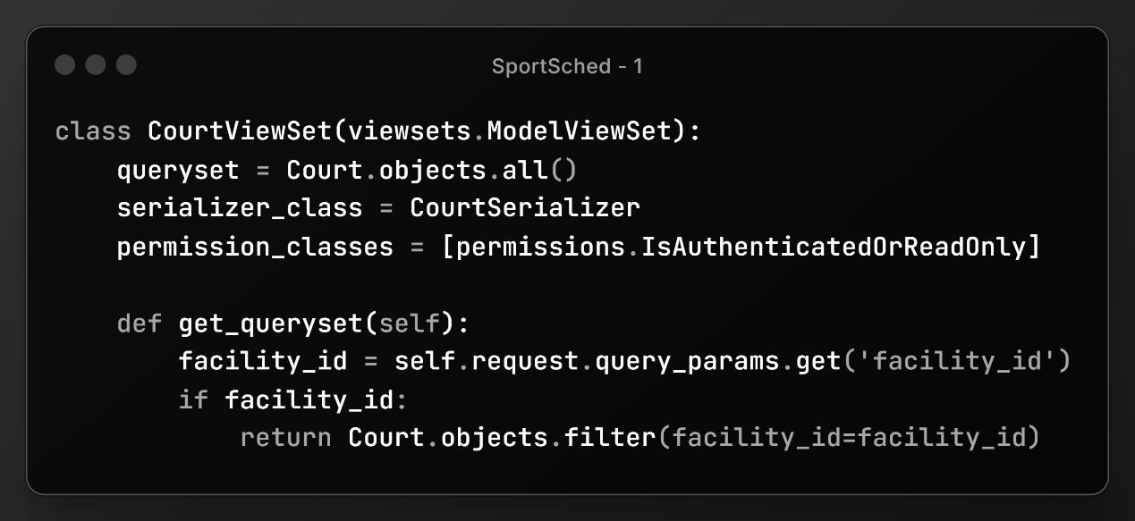

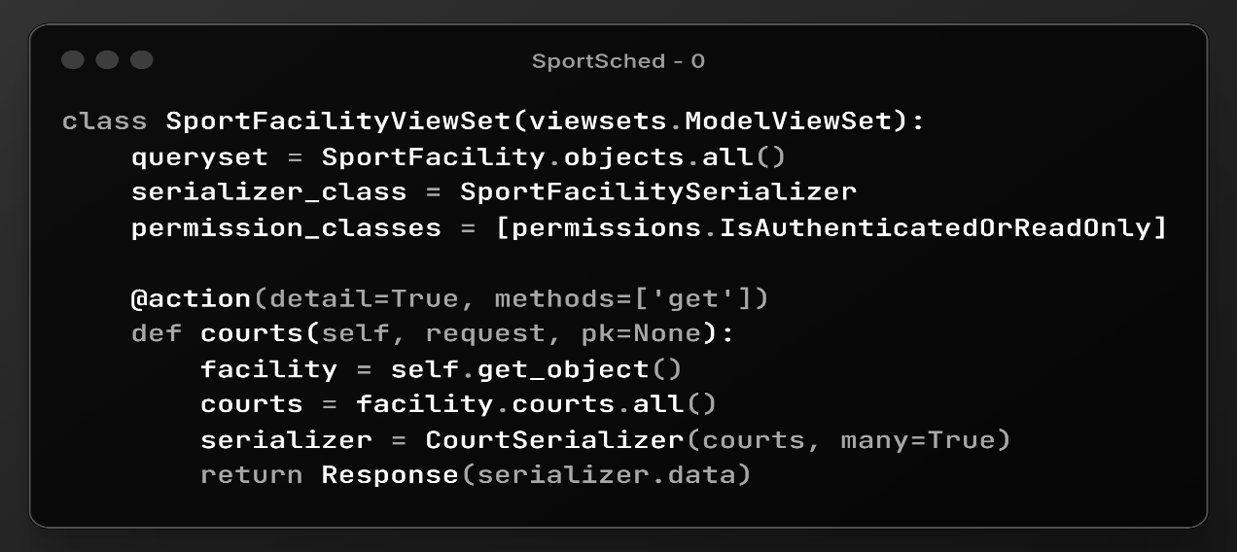

These are some of the view set code snippets involved in the running of the code**3.**

**Frontend Implementation**

The frontend is created using React, which allows for the development of a dynamic and interactive user interface. React components manage user interactions, display available facilities, and allow users to make reservations.

React Component for Facility Listing

The following is a React component that fetches and displays a list of available facilities:

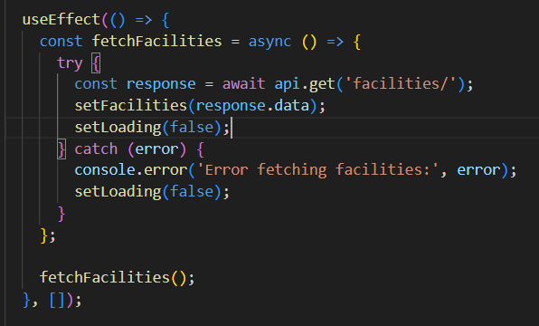

React Component for Making a Reservation

Here is a React component that lets users reserve a facility

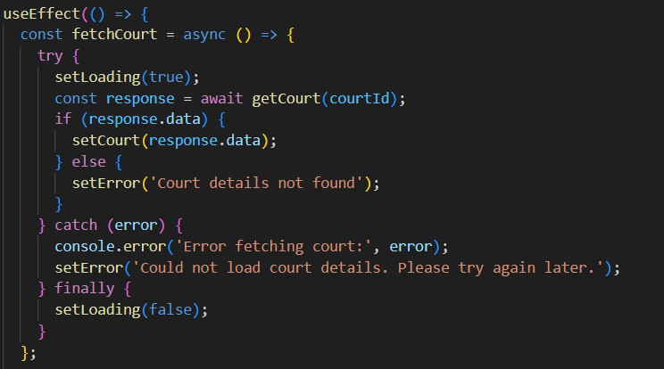

4. Backend and Frontend Integration

Once the backend and frontend are implemented, they need to communicate via API requests. React sends data to the Django backend using fetch requests. The backend processes these requests and responds with the appropriate data.

+Here is how React interacts with Django for making reservations:

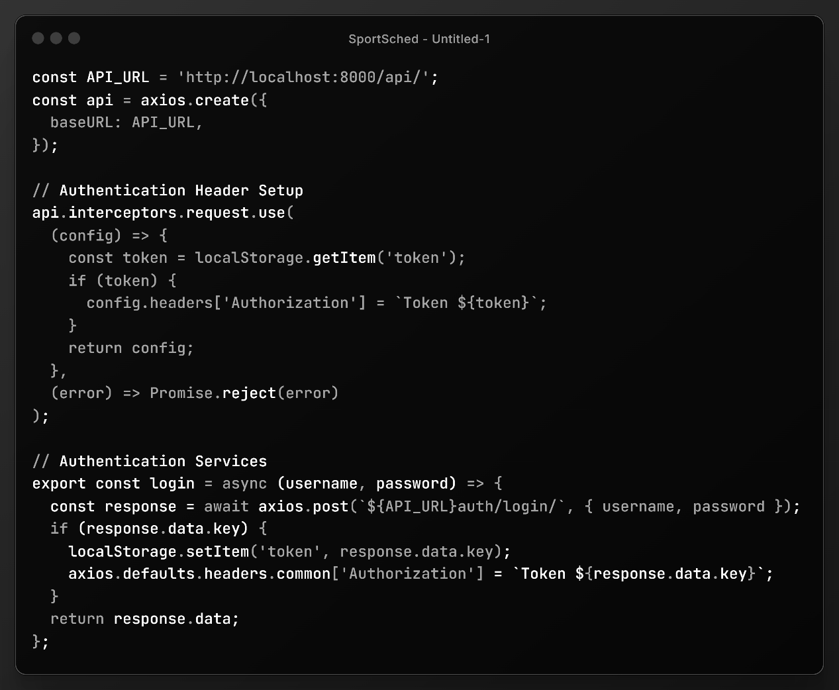

This is the code snippet that shows the api linking that enable the connection between backend and frontend.

5. Testing and Deployment

The final phase of the project involves evaluating the system to ensure everything is working correctly. After testing, the system is deployed to a web server using Apache or Nginx. The React application is built for production using the following command:

npm run build

This generates static files, which are then served by the web server.

**5.2 Execution steps**

**Setup Instructions**



Run the above set of commands to set up the prerequisite packages and the environment to run the project.

**5.3 Result**

The result of this small project is a fully operational web-based sports facility booking system called SportSched. This platform has been carefully crafted to prioritize user experience, system performance, and practical use. It has been thoroughly evaluated and is now stable and ready for deployment. Utilizing contemporary web technologies such as React for the frontend and Django for the backend, it follows industry best practices in software development and can be easily moved into a production setting.:

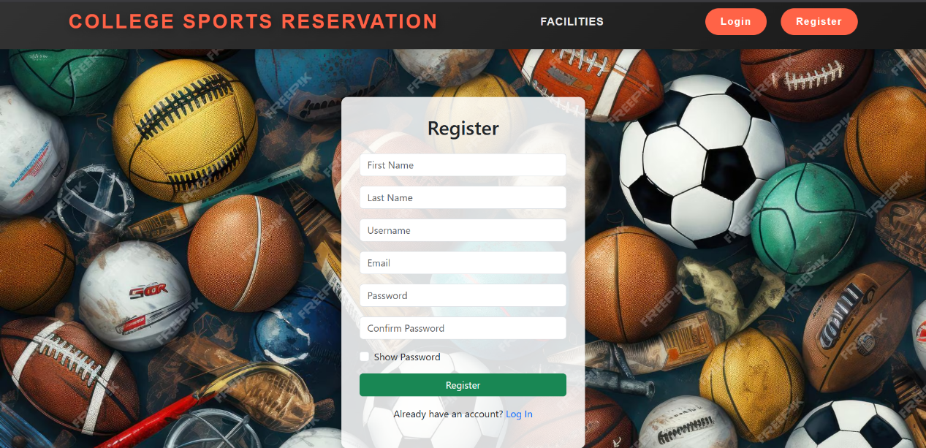

**Fig 1.1 Registration page**

The image above illustrates the User Registration Page of the SportSched system, which acts as the gateway for new users to access the platform. This page is carefully crafted to provide a smooth and user-friendly registration experience, making it suitable for individuals with limited technical skills. Upon submission of the registration form, the entered data—such as name, email, academic information, and password—is initially validated on the frontend to ensure completeness and correct formatting. After validation, the data is transmitted to the backend, where it is processed by the Django framework. The backend securely stores the information in the system's SQLite3 database, resulting in the creation of a new user account for future logins and access to the reservation system's features.

Furthermore, the registration page integrates essential security features, including a password policy that mandates minimum character length, the use of both uppercase and lowercase letters, and the inclusion of numbers or special characters.

These protocols are designed to prevent weak passwords, thereby bolstering the security of user accounts and safeguarding the system against threats like unauthorized access or brute-force attacks. The page's design is sleek and responsive, built with React to ensure a contemporary appearance and fluid interaction. Users receive real-time feedback while completing the form, which minimizes input errors and assists them in successfully creating their accounts. Consequently, the registration page not only streamlines user onboarding but also establishes a foundation for the system's reliability, security, and user-focused design.

Registration table:

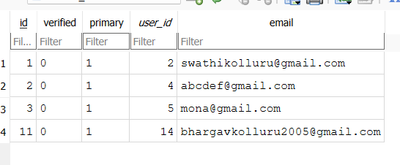

Table 1.1 **User emails table/database**

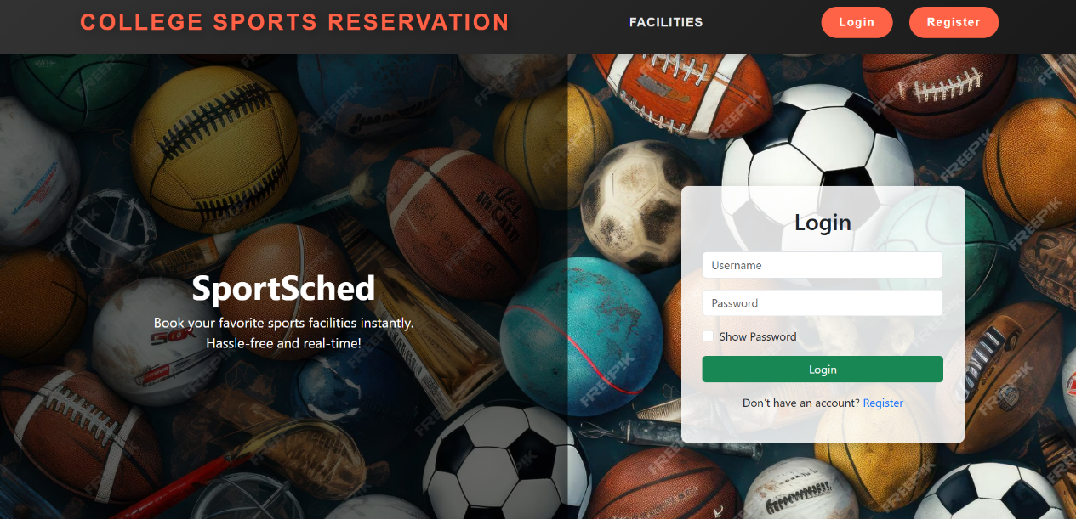

**Fig 1.2 login page**

The image above illustrates the Login Page of the SportSched system, which acts as a secure entry point for users who have previously registered on the platform. This page is vital for upholding the system's integrity and privacy by ensuring that only authorized individuals can access its functionalities.

When users arrive at the login page, they are required to input their registered credentials, specifically their email address or username along with the associated password. After submission, these details are captured by the frontend and transmitted to the backend, where the Django authentication framework takes charge. The system queries the SQLite3 database to verify if the provided credentials correspond to any existing user records.

If the entered email or username is located in the database and the corresponding password aligns with the one stored for that account, the user is successfully authenticated. Upon confirmation of authentication, the user gains access to the website and is redirected to their personalized dashboard or homepage, enabling them to view and reserve sports facilities.

In instances where the provided credentials are incorrect—either due to an unregistered email or a password mismatch—the system denies entry. Instead, an error message is presented on the screen, clearly indicating that the login attempt was unsuccessful. This feedback assists the user in correcting their credentials or recovering their account if necessary.

This login mechanism not only safeguards the platform from unauthorized access but also enhances user experience by providing immediate and informative feedback. It is a crucial element of the system’s overall security framework and plays a significant role in protecting user data and booking privileges from misuse.

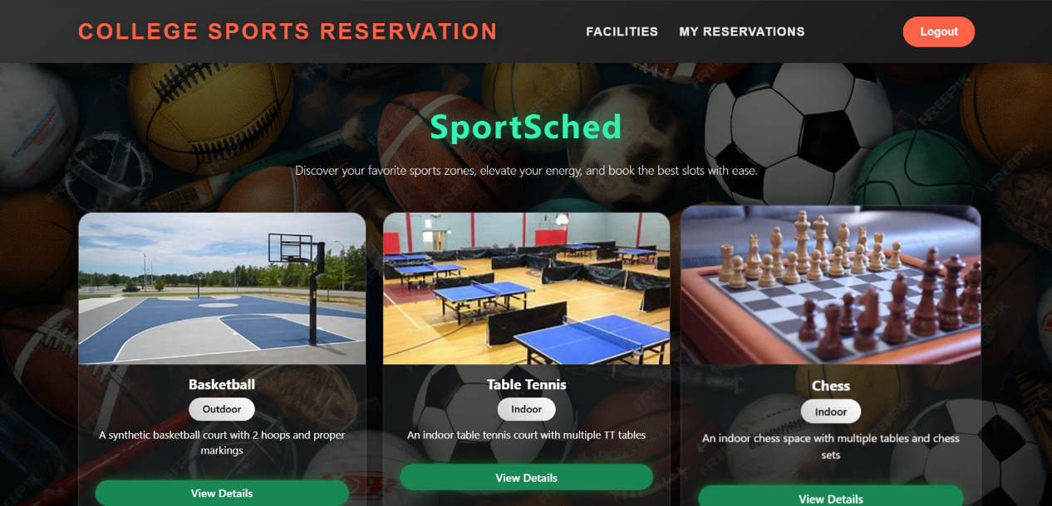**Fig 1.3 Facilities Page**

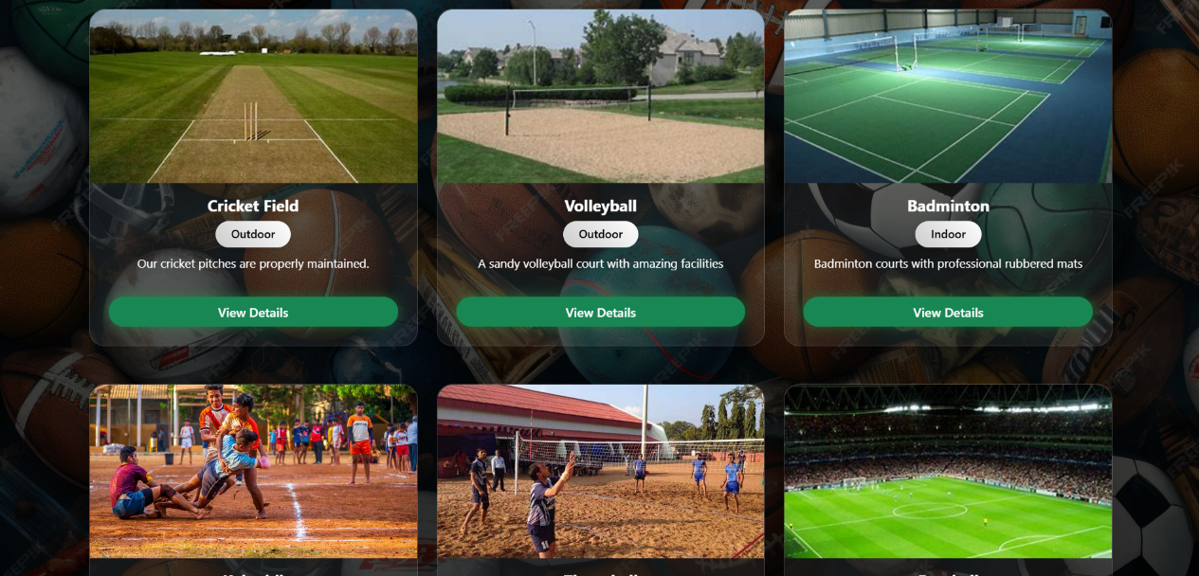 **Fig1.4 Continuation to the Facilities Page**

The images above showcase the Home Page of the SportSched system, serving as the primary navigation hub for all platform users. This page is designed with user accessibility and experience in mind, allowing easy access from any part of the website by clicking the prominently displayed 'College Sports Reservation' title in the header. This feature ensures users can effortlessly return to the main page without navigating back through multiple steps. Upon arrival at the home page, users encounter a well-organized overview of all sports facilities available within the institution. The layout is optimized for maximum visibility, enabling users to quickly browse options and discover facilities that align with their preferences. Each facility is accompanied by relevant visuals and details, including the type of sport, current availability, and booking status. This central page is crucial for helping users plan their activities efficiently.

By providing a comprehensive snapshot of the entire facility ecosystem, it minimizes the time and effort required to locate a specific court or field. Additionally, it serves as a launch point for making reservations, allowing users to click on any listed facility for more information or to book a time slot. Developed using React, the home page is not only aesthetically pleasing but also dynamic, updating in real-time to reflect changes in facility availability. This feature ensures users always have access to the most up-to-date information, which is particularly vital during peak booking times. In summary, the home page significantly enhances user engagement by offering a streamlined, visually intuitive platform for exploring, evaluating, and accessing various sports resources. It embodies the project's objective of simplifying sports facility management while encouraging greater participation through transparency and ease of access.

Facility table/database:

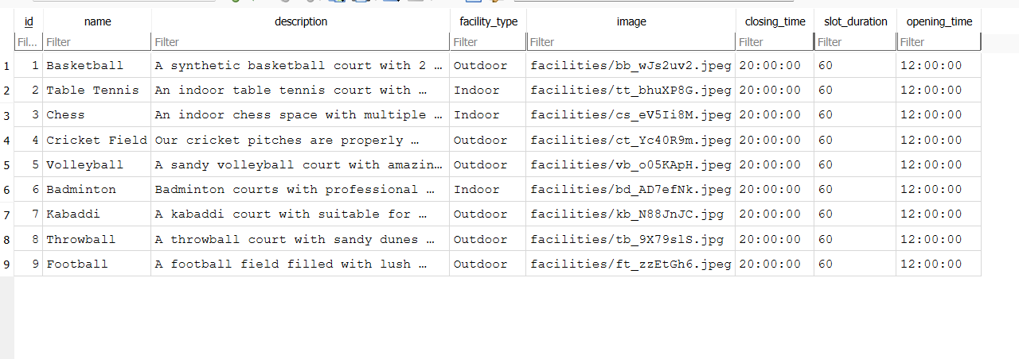Table 1.2 Facility table/database

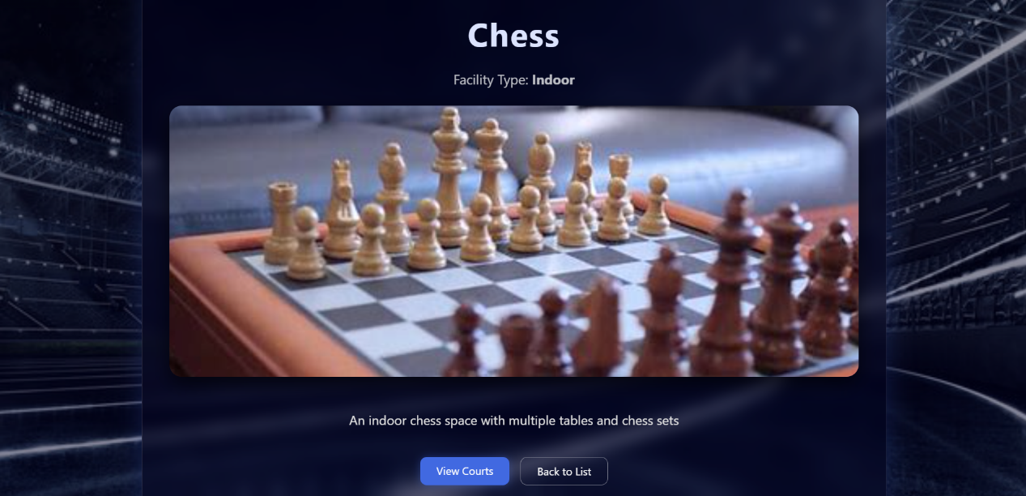

**Fig1.5 Interface between the sports page and the courts list page**

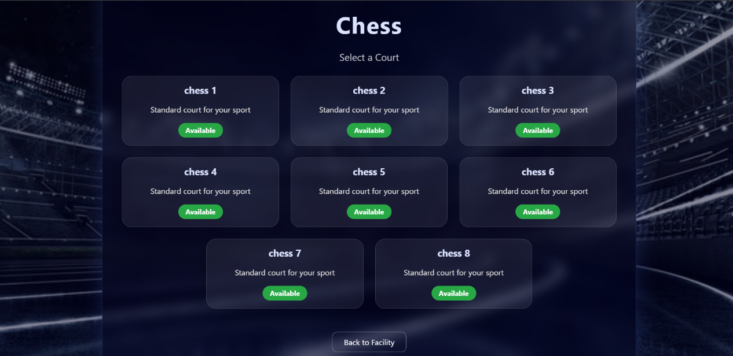 **Fig1.6 Courts Page**

The above image illustrates the Courts Page of the SportSched system, a crucial interface that provides users with the ability to view and select from a range of sports courts available for reservation. This page acts as a focused extension of the home page, narrowing down the user’s choices specifically to court-based facilities such as basketball courts, tennis courts, badminton courts, and others offered by the institution.

Upon reaching this page, users are presented with a well-organized and visually intuitive layout where each available court is clearly listed.

Information accompanying each court typically includes the court type, its current availability status, and possibly a visual or icon representing the facility for easier identification. This design enables users to make informed choices quickly, reducing the time and effort spent in searching for a suitable venue.

The courts page serves as a gateway to the booking process. When a user clicks on their preferred court, they are redirected to a more detailed interface where they can view available time slots and confirm their reservation. The interactive design ensures that all selections are dynamic and updated in real time, preventing double bookings and ensuring transparency.

Behind the scenes, the page is powered by the Django backend, which communicates with the SQLite3 database to retrieve accurate court availability data.

React is used on the frontend to ensure a smooth and responsive user experience, with transitions and data updates happening seamlessly without needing to reload the entire page.

Overall, the courts page simplifies the process of selecting a facility and plays a key role in achieving the system’s mission of streamlining sports facility management. By offering users an efficient and engaging way to browse and select courts, it significantly enhances both the functionality and appeal of the platform.

Courts table/database:

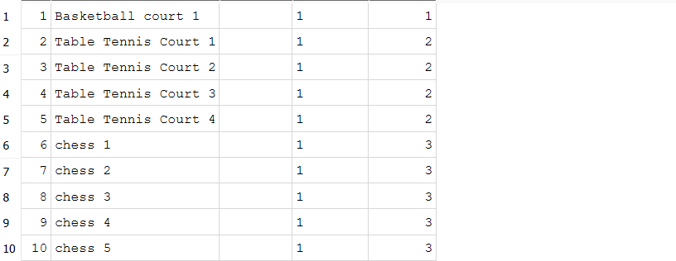

**Table 1.3 Courts table/database**

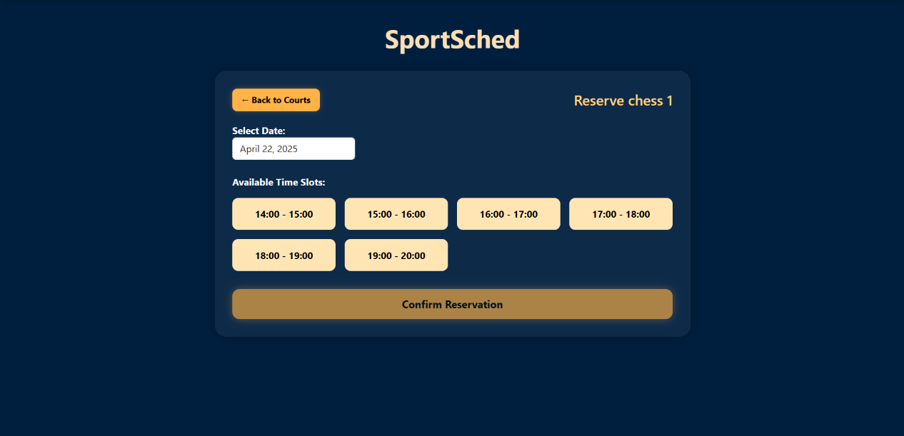 **Fig1.7 Reservation Table**

The image above illustrates the Reservation Page of the SportSched system, a crucial and interactive element of the platform. This page is tailored for users to select a time slot for booking a chosen sports facility, such as a court or field, based on its current availability. It features a user-friendly interface that guides users through the booking process step-by-step. Upon selecting a specific court or facility from the courts page, users are directed to this reservation interface, where available time slots for the selected day are dynamically shown, allowing users to easily identify which slots are open and which are already reserved. The interface is designed to be intuitive and responsive, utilizing React to ensure real-time updates on availability, thereby preventing double-booking. Users can simply click on their desired time slot to start the reservation process. Once a slot is selected, the system checks its status against the SQLite3 database via the Django backend. If the slot is confirmed as available, it is booked immediately, and the user receives a confirmation message. In the rare event that the slot has just been taken by another user, an error message will appear, prompting the user to choose a different available slot. To improve usability, the page may include features such as calendar navigation, filters for specific dates or facilities, and an option to view past reservations.

The reservation process is intentionally designed to be simple and efficient, promoting regular use and easy access for all students. Ultimately, the reservation page embodies the primary goal of the SportSched system: to streamline and digitize the facility booking process, offering students a fair, organized, and real-time method for securing access to sports facilities.

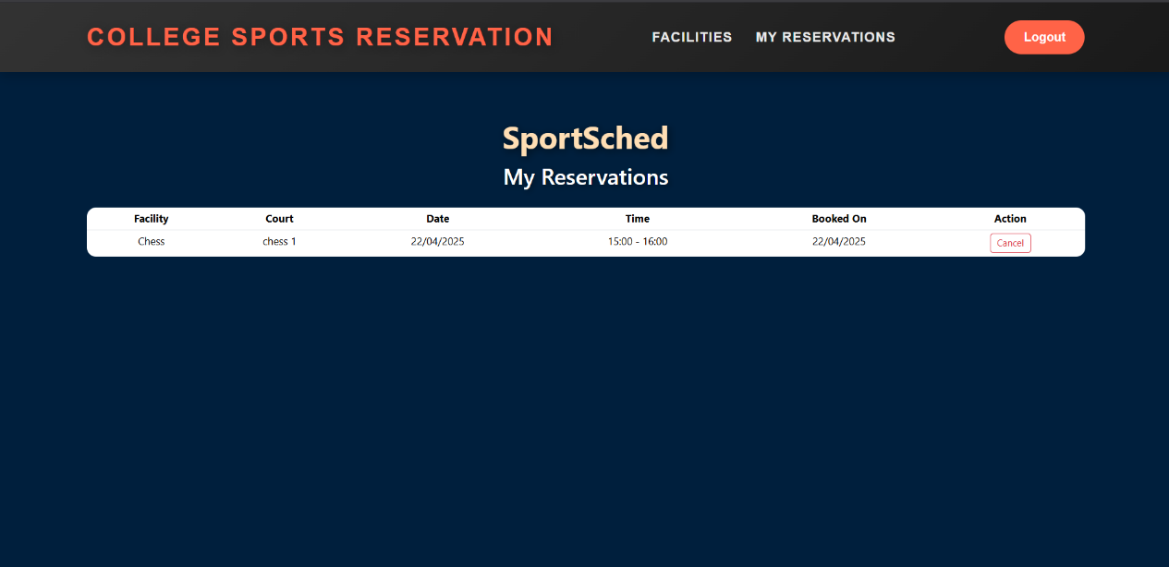**Fig1.8 My Reservations Page**

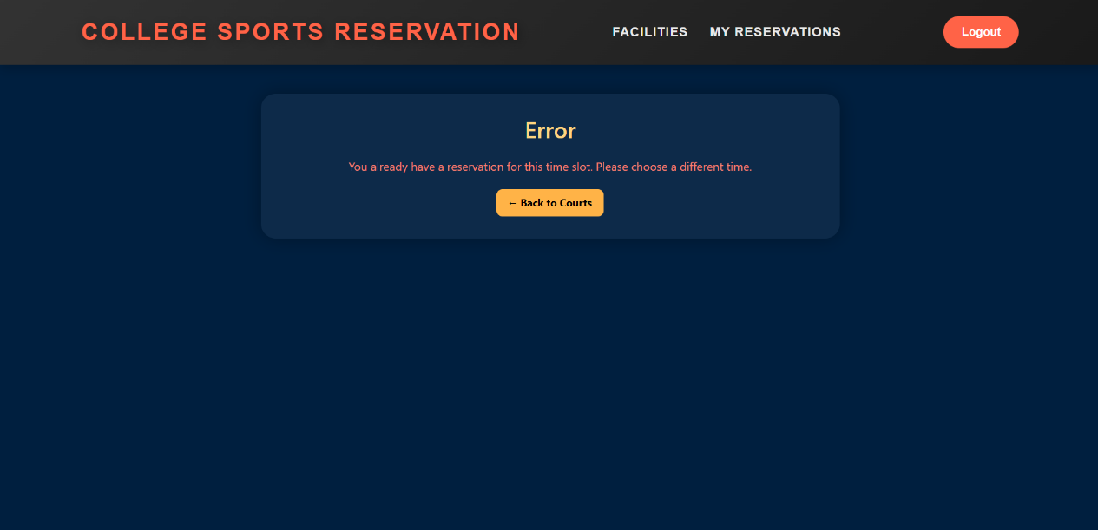**Fig 1.9 Error 1**

The above image illustrates the page that showcases reserved facilities and their corresponding time slots, offering users a well-structured overview of all their active bookings.

This interface enables users to monitor their reservations by displaying each facility along with key information such as the court name, date, and time slot. It promotes transparency and helps avoid double-booking by providing users with a detailed perspective of their scheduled events. The system is integrated with the backend through Django and utilizes a real-time connection to the SQLite3 database, ensuring that the information is consistently current. Conversely, the accompanying error screen appears when a user tries to book a time slot that has already been taken. In such cases, the system identifies the conflict during the validation process and quickly presents an error message, notifying the user that the chosen slot is no longer available. This mechanism upholds data integrity and enhances user confidence by delivering prompt, informative feedback while ensuring a seamless and secure booking process.

Time slots database/table:

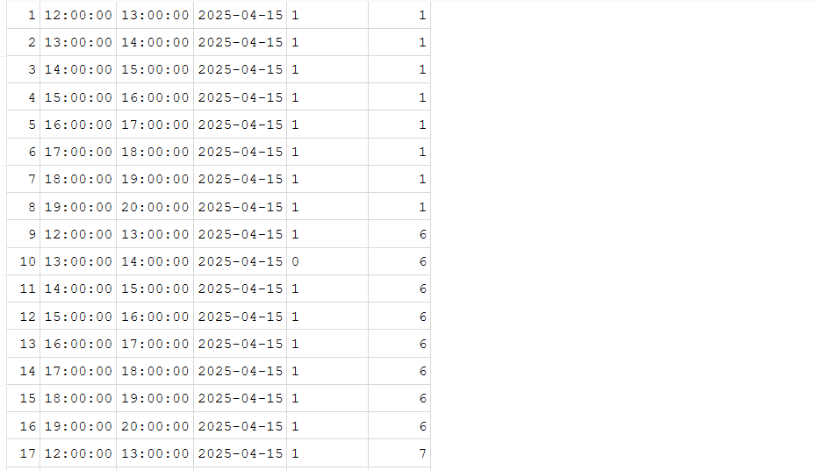

**Table1.4 Time slots database/table**

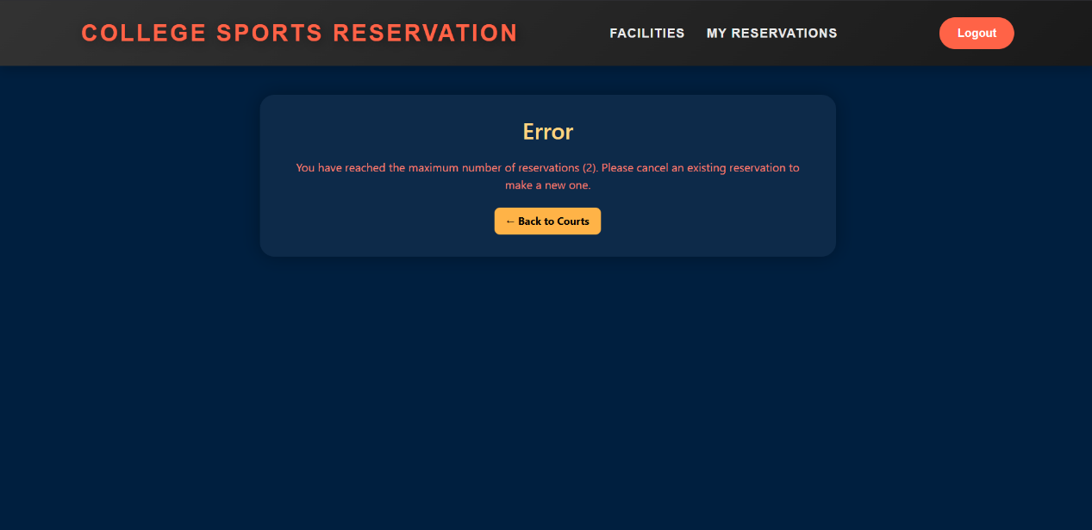**Fig2.1 Error 2**

The SportSched system incorporates a built-in restriction feature aimed at ensuring fair access to sports facilities for all users. When a user attempts to surpass this set reservation limit, the backend, built with Django, checks the SQLite3 database to verify the total number of bookings linked to that user. If the request breaches the reservation policy, the system promptly displays an error message. The error message is presented in a user-friendly format, offering clarity and guiding the user to either modify their booking schedule or return later. By proactively conveying such limitations, the system not only improves user experience but also upholds the discipline and structure necessary for effective facility management in a shared environment.

Reservations database/table:

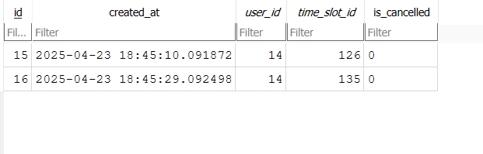**Table 1.5 Reservations database/table**

**6.Conclusions and Future Scope**

**Conclusion:**  The SportSched system effectively addresses the challenges associated with traditional manual booking methods by offering a streamlined and automated approach to sports facility management. Its user-friendly interface and real-time availability features prevent double bookings, lessen administrative burdens, and guarantee equitable access to courts and other sports facilities. By digitizing the reservation process, it fosters transparency, enabling students and faculty to participate in sports activities without unnecessary delays or conflicts. The system's modular and scalable architecture is a notable advantage, allowing for easy customization to meet the unique needs of various educational institutions. Whether utilized in universities, schools, or sports academies, it can be tailored to fit different facility types and user demands. Furthermore, the automation capabilities assist facility managers in monitoring and regulating usage patterns, ensuring effective resource allocation and maintenance scheduling. In summary, SportSched enhances facility management efficiency and promotes increased student engagement in physical activities by simplifying access to sports facilities. By minimizing manual intervention and reducing booking errors, the system offers a more user-friendly and dependable method for managing sports resources.

**Future Scope:** While the existing system is robust and functional, there are several potential enhancements that could greatly improve user experience and system efficiency. A key future improvement is the development of a dedicated mobile application for both Android and iOS devices. In our increasingly mobile-centric society, smartphones have become the primary means for users to engage with digital services. By creating a mobile app, SportSched can broaden its accessibility and functionality, enabling users to book slots, receive real-time notifications, and manage their reservations directly from their smartphones. This would eliminate the necessity for users to rely on desktop or laptop computers, thus providing convenient access and streamlining the booking process. The mobile application could offer a sleek and user-friendly interface, designed for touch interactions, allowing users to swiftly check available time slots, verify court availability, and finalize their bookings in mere seconds. Push notifications could be incorporated to inform users about upcoming reservations, cancellations, or last-minute openings, ensuring they remain updated in real-time. Furthermore, a mobile app would facilitate additional features such as location-based services, notifying users of nearby available courts, and calendar integration for automatic syncing of bookings with personal calendar applications. Enhancements like dark mode, offline access to booking history, and voice command capabilities could further elevate the user experience. From a management standpoint, the mobile application could provide an admin dashboard for facility managers, allowing them to monitor bookings, send updates, or approve/reject reservations remotely, significantly enhancing operational efficiency and responsiveness. In summary, the creation of a mobile app will not only boost user engagement but also align the system with contemporary usability standards.

**7.Challenges/Difficulties Faced**

During the project's development, we encountered numerous challenges that tested our technical abilities, teamwork, and time management skills. One of the first obstacles was mastering Git for version control. As novices, pushing code to a shared repository proved to be complicated. We frequently faced issues such as merge conflicts when several team members edited the same files, and there were occasions when code was overwritten or became unsynchronized due to improper branching or committing practices. Gaining proficiency in Git—learning about pull requests, merges, conflict resolution, and maintaining clean commits—required time but ultimately proved beneficial.

Team collaboration also presented both advantages and challenges. Working with multiple team members necessitated clear communication and defined roles. Misunderstandings sometimes resulted in duplicated efforts or missed tasks. We needed to hold regular meetings to update our progress, clarify roles, and ensure alignment with the project's overall objectives. Creating a mutual understanding of the workflow and maintaining consistent collaboration were crucial for smooth progress.

Time management emerged as one of the most pressing challenges. As final-year students, we had to balance academic responsibilities, exam preparation, and personal commitments alongside this project. Dedicating specific hours to development, testing, documentation, and team meetings was vital to meet our deadlines. Unforeseen technical problems occasionally caused delays, prompting us to adjust our schedules and put in extra hours to remain on track.

One of the most intricate technical challenges was implementing real-time updates within the system. For instance, ensuring that when one user booked a slot, it was immediately reflected across all user interfaces required a strong grasp of asynchronous operations, backend synchronization, and effective database interaction. This involved utilizing WebSocket-like technologies or periodic polling methods to create a real-time experience.

**Bibliography**

1. Django Project Documentation. Retrieved from https://docs.djangoproject.com/  
2. ReactJS Official Documentation. Retrieved from https://reactjs.org/docs/getting-started.html  
3. SQLite3 Documentation. Retrieved from https://www.sqlite.org/docs.html  
4. Real Python Tutorials – Django REST Framework. Retrieved from https://realpython.com/  
5. Stack Overflow. Retrieved from https://stackoverflow.com/  
6. GitHub Repositories related to Django and React Integration.